**ROLLING TERRACE PTA**

**2016-2017**

**PTA MINIGRANT PROGRAM**

***APPLY NOW!***

|  |  |
| --- | --- |
| **Goal:** | Provide small grants to fund special programs, projects, items, and/or events that benefit individual classes, teachers, students, and the Rolling Terrace School Community. |
| **Who Can Apply?** | All teachers, staff and parents, individually or in groups. |
| **When is the Deadline?** | We intend to award minigrants in two cycles, one in the Fall and one in the Winter.   * **For Fall Cycle grants, please apply by October 14, 2016** * **For Winter Cycle grants, please apply by January 13, 2017** |
| **How do I Apply?** | Review the Grant Guidelines and complete the attached application and email it to Rosanne Rushing (rosannerushing@hotmail.com) or place in the PTA mailbox in the school mailroom. |
| **Application Process?** | A group of volunteers from the PTA will review the applications and make the final determination on awards. The program is competitive and not all applications will be awarded funds. Mini grants are only possible because of membership dues and donations, so please consider joining if you haven’t already! http://www.rollingterracepta.org/membership |
| **How much can be requested?** | The maximum amount for any single award is $400. *Requests for lower amounts are strongly encouraged.* |
| **What Can the Funds be Used For?** | Funds may be used for the materials, books, resources, fees, or services requested in your application. |
| **Process for Receiving Funds?** | Awardees make their purchases, save receipts, and request reimbursement, OR a request for a check in advance from the PTA Treasurer may be made. The PTA is NOT able to provide cash up front for any purchases. For more information, please see the attached Minigrant Guidelines. |
| **I Need Help . . . I’m not Sure How to Write Up My Grant Application** | If you need help writing up your grant, or have questions about how an idea you have may fit into the minigrants program, please let us know! We are happy to help out with these kinds of questions! |

***To all Teachers, Staff, and Parents of Rolling Terrace Elementary:***

We are pleased to kick-off another year of minigrants programs funded by the PTA. Minigrants can be used to help fund special programs, projects, items, and/or events that benefit individual classes, grades, all students, teachers or the Rolling Terrace School Community. In the past, grant awards have purchased new materials for classrooms and school projects, programs, events, and school presentations.

The PTA has approved $5,000 for minigrants projects for the 2016-2017 school year. Applications will be accepted in two cycles (fall and winter) during the 2016-2017 school year. The full $5,000 is available now and all teachers, parents, and staff are eligible to apply. The maximum amount granted per application is $400. Requests for smaller amounts are also encouraged.

**The PTA is also funding the Sr. Cancel Memorial Literacy Grant** **for the 2016-2017 school year grant cycle.** Please review the specifics of this grant in the application below. Applicants must specify they are applying for these funds. **The literacy grant is specified in the amount of up to $400.00.** All rules and deadlines for regular minigrants also apply to this special grant.

Please use the attached application to apply and email it Rosanne Rushing ([rosannerushing@hotmail.com](mailto:rosannerushing@hotmail.com)). A copy of the application is also available on the school’s shared drive and PTA website. Upon your submission you will receive an email confirmation that your application has been received. If you have any questions, please contact Rosanne Rushing.

TIPS for Completing the Minigrant Application and

Spending a Minigrant Award

Please answer all questions on the application form clearly and with as much detail as possible. In previous years, we’ve had to do a lot of follow-up to get additional information about your projects. The more information you can provide on the application, the easier the selection process will be.

Specify clearly what the money you are requesting will go towards. For example, if you are requesting $300 for books, please clarify which books, how many you need and how much is the cost per book. The PTA prioritizes minigrants that work across classrooms and benefit the maximum number of students possible.

Specify an estimated timeline of when your project will be completed.

If awarded a minigrant, please fulfill your project as close to the estimated timeline as possible. We understand that plans may change throughout the year and some projects may not be carried out to fruition. Please stick to your timeline as much as possible and if your plans do change, please let us know.

If you are not able to complete your project, let us know so that we can offer funding to someone else. Please let us know if you do not use your award so that we can add that amount to the next mini-grant award cycle. Please understand that mini-grants cannot be carried over to the following year.

All mini-grants reimbursements or check requests should be for the specific amount of your purchase or project. Funding cannot be for more than the initial mini-grant awarded to you.

***Consider whether your application corresponds to MCPS objectives.*** The PTA will confer with RTES administration about all applications to be sure applications are consistent with MCPS curriculum and RTES activities.

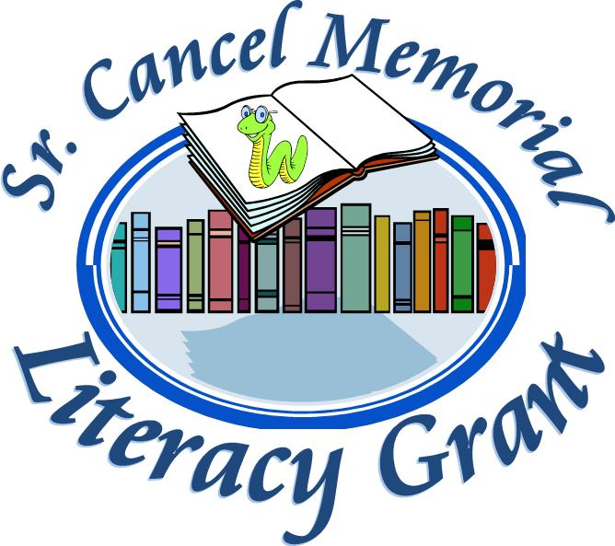

The **Sr. Cancel Memorial Literacy Grant** is a new part of the RT-PTA Mini-Grant program. This grant will work just like a regular Mini-Grant, with the same outlined rules, deadlines, and guidelines as a regular mini-grant.

On March 6, 2013, Domingo Cancel-Roman, a fifth grade teacher at Rolling Terrace Elementary School, passed away unexpectedly. He was a long time staff member and had worked at MCPS for more than 22 years. Sr. Cancel was a beloved teacher who had a true passion for reading. He often stressed the overall importance of literacy not just for reading based curriculum but as a key component in the success of a student as a whole. Sr. Cancel also had a passion for reaching out to children in need . . . often children who faced various barriers to success in the classroom or at school. He had a lasting impact on many students who passed through Rolling Terrace. ***This grant is a special way to remember him and honor his memory in the best way possible: support literacy at Rolling Terrace!***

**C:\Users\Diana\AppData\Local\Microsoft\Windows\Temporary Internet Files\Content.IE5\II7K5KAP\MC900019306[1].wmf*To apply for the Sr. Cancel Memorial Literacy Grant***, we ask that you complete the Mini-Grant application as outlined. The grant, however, must be for a literacy based project or endeavor. **The grant total is $400.00.** As with any grant application, be as detailed as possible and let our grant committee know what your plans are, what you would like to do, and how it will impact or support literacy at Rolling Terrace. Moving forward, we will recognize each winner of the Sr. Cancel Memorial Literacy Grant.

***We look forward to receiving your application!***

**The 2016-2017 Rolling Terrace PTA Mini-Grants Program**

**Application Form**

Please answer all of the questions in detail. Your answers will be used to evaluate each request. If we have additional questions, we may call or email you for more information.

.

**Email your application to** **Rosanne Rushing (rosannerushing@hotmail.com) or place your application in the PTA mailbox in the school’s mailroom.**

**Deadlines: October 14, 2016 (for Fall Cycle) or January 13, 2017 (for Winter Cycle)**

* ***Please check this box if you would like this application to be considered for the Sr. Cancel Memorial Literacy Grant.***

1. Please provide all contact details for the Primary Contact below.

Name:

Position:

Email address:

Phone number:

(A number other than the school phone number)

Additional Applicant(s) name, position and contact information:

1. Name and brief description of your proposed project:
2. How will you use the funds? Please be as detailed as possible. If purchasing items with minigrant funds, please describe the item(s), include cost per item and how many of each you intend to purchase. If available, please attach a web link or a copy of ordering information (like a page from a catalog) to this application.
3. Amount Requested:

Minimum amount requested to partially support your project $__________

Maximum amount requested to fully support your project $ __________

(The maximum amount allowed is $400).

1. What is the proposed timeline for your project? When do you expect to use the funds? (Please note that if you don’t use it, you lose it. Minigrants cannot be carried over to the following year.)
2. Who will benefit from the project? Please list the grade(s) and number of students. If your project benefits a select group of students, please describe this group.
3. Please specify if and how your project relates to either the curricula, classroom learning, character education, or topics not part of the required curricula.

Applications should be emailed to Rosanne Rushing (rosannerushing@hotmail.com) or placed in the PTA mailbox.